**Behavioural Data Analysis**

**Summary of Project:**

**Problem Statement:**

This project involved a comprehensive analysis of the behavioural_dataset.csv, a dataset containing individual demographic, financial, and loan-related information.

**Project Objective**:

The primary objective of this project was to extract meaningful insights from the behavioral dataset to understand consumer behavior patterns, identify key factors influencing purchasing decisions and loan status, and ultimately provide actionable intelligence for strategic business initiatives.

**Data Source:**

The analysis was conducted on the behavioral data, comprising 99 entries and 8 distinct attributes, including Age, Profession, Marrital Status, Education, No of Dependents, Personal loan, Total Salary, and Price.

**Methodology:**

The project employed exploratory data analysis (EDA) techniques. This included:

* Data Inspection: Initial examination of the dataset's structure, data types, and missing values.
* Descriptive Statistics: Calculation of summary statistics for numerical columns and frequency distributions for categorical variables.
* Correlation Analysis: Assessment of relationships between numerical variables, particularly focusing on the Price and Total Salary.
* Cross-Tabulation and Grouped Analysis: Examination of how categorical variables (e.g., Profession, Education, Marrital Status) relate to Personal loan status and average Price.

**Demographic Influence on Purchase Price:**

* Profession: Salaried individuals (mean price of ~1.23 million) tend to spend more on purchases than Business professionals (mean price of ~1.12 million).
* Education: Post Graduates (mean price of ~1.21 million) show a slightly higher average purchase price than Graduates (mean price of ~1.16 million).
* Marital Status: Married individuals (mean price of ~1.22 million) on average purchase higher-priced items than Single individuals (mean price of ~1.04 million).
* Actionable Insight: Businesses can refine their target audience based on these demographic attributes. For example, marketing high-value products to married, salaried post-graduates may yield better conversion rates.
* Personal Loan Distribution Across Demographics: While not showing drastic differences, the dataset reveals the distribution of personal loan holders across different demographic groups:
* Salaried individuals have a higher absolute number of personal loans.
* The proportion of individuals with personal loans is relatively consistent across different education levels (Graduates vs. Post Graduates) and marital statuses (Married vs. Single).
* Actionable Insight: Financial institutions might want to delve deeper into the specific financial behaviors or needs of Salaried individuals that lead to a higher uptake of personal loans.
* Limited Impact of Dependents on Price/Salary: The number of dependents has a very weak correlation with Price (0.09) and Total Salary (0.23), suggesting it's not a primary factor influencing an individual's purchasing power or income in this dataset.
* Actionable Insight: While No of Dependents is valuable for understanding household size, it might not be a strong predictive feature for purchase behavior or income in this specific context.

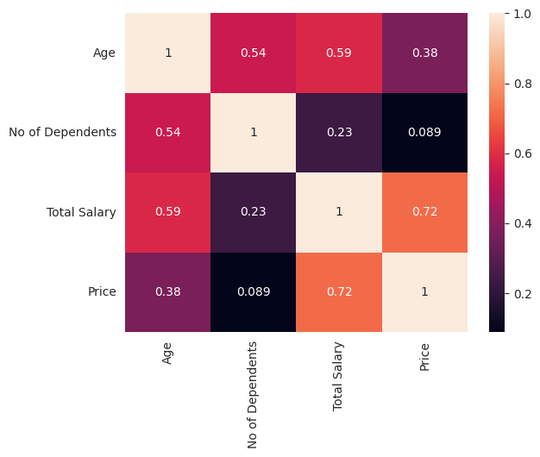

**Key Insights and Outcomes**:

The analysis yielded several significant insights:

* Strong Influence of Salary on Purchase Price: A robust positive correlation was identified between Total Salary and Price, indicating that higher earners tend to purchase more expensive items. This highlights the importance of income as a predictor of purchasing power.
* Age and Financial Growth: Age was found to be positively correlated with Total Salary and No of Dependents, suggesting that income and family size generally increase with age.
* Demographic Segmentation for Pricing: Distinct differences in average Price were observed across various demographic groups. Specifically, Salaried individuals, Post Graduates, and Married individuals showed a propensity to purchase higher-priced items compared to their counterparts.
* Personal Loan Patterns: While personal loan uptake was distributed across professions, education levels, and marital statuses, Salaried individuals showed a higher absolute number of personal loans.

**Project Significance and Applications**:

The insights derived from this project are invaluable for businesses in several areas:

* Targeted Marketing: Enabling the creation of more effective marketing campaigns by identifying specific customer segments (e.g., high-income, married post-graduates) most likely to purchase certain products or services.
* Product Development & Pricing Strategies: Informing decisions on product features and pricing tiers to align with the purchasing capabilities and preferences of different customer segments.
* Customer Segmentation: Facilitating the development of robust customer segmentation models for personalized engagement strategies.
* Strategic Planning: Providing data-driven intelligence for business expansion, market penetration, and resource allocation.

In essence, this project successfully transformed raw behavioural data into actionable insights, providing a foundation for data-driven decision-making and enhancing business intelligence.

This dataset is highly useful for businesses, financial institutions, and marketers seeking to understand and predict consumer behavior. Here’s Why:

* Customer Segmentation: The demographic and financial data allows for the creation of distinct customer segments. Businesses can group customers based on age, profession, marital status, education, and salary to tailor products, services, and marketing messages more effectively.
* Targeted Marketing: By understanding which customer segments are more likely to have a personal loan or purchase higher-priced items, companies can optimize their marketing campaigns, directing resources towards the most promising leads.
* Product Development and Pricing: Insights into the relationship between salary and Price, or demographic factors and Price, can inform product development strategies and pricing models. For instance, businesses can identify features or price points that appeal to specific customer groups.
* Risk Assessment (for Financial Institutions): While limited in scope without more detailed loan information, the personal loan column, combined with other attributes, can offer preliminary insights into potential risk factors for loan applicants.
* Strategic Decision Making: The dataset provides a quantitative basis for strategic decisions related to market entry, expansion, or focus areas. For example, if a business observes a strong correlation between education level and willingness to pay higher prices, it can prioritize marketing in areas with a higher concentration of educated individuals.

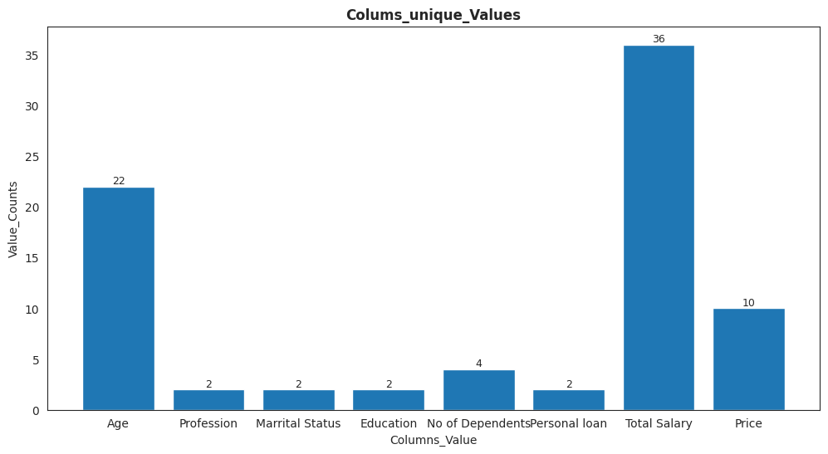

GitHub link: [‘https://github.com/Neethu0207/Market-Analysis/blob/main/EV.ipynb’]